# Question:

Lab 5

Write a java program that displays a common welcome message to greet all the students in an orientation program. Include a static method in your program that finds the occurrence of subjective pronouns in the message string. The program should display the identified subjective pronouns, the number of occurrences and the starting and ending index of it.

# Code:

import java.util.ArrayList; import java.util.Scanner;

class students { String name; int id;

static String Welcome_message = "I would like to extend a warm welcome (or welcome back) as you begin what promises to be an exciting and memorable year.";

static void Find_subjective_pronouns() {

String[] subjective_pronouns = {"I", "You", "He", "She", "It", "We", "They", "Who", "What"};

int[] count = new int[subjective_pronouns.length];

String[] welcome_message = Welcome_message.split(" ", -1);

ArrayList<Integer>[] start_index = new ArrayList[subjective_pronouns.length];

for(int i = 0; i < start_index.length; i++) {

start_index[i] = new ArrayList<Integer>();

}

int total_count = 0;

i++) {

int index = 0;

for(int i = 0; i < welcome_message.length;

for(int j = 0; j <

subjective_pronouns.length; j++) {

if(subjective_pronouns[j].equalsIgnoreCase(welcome_me ssage[i])) {

total_count++; count[j]++;

start_index[j].add(index); break;

}

}

index += welcome_message[i].length();

}

System.out.println("The total number of subjective pronouns in the Welcome messgage: " + total_count);

System.out.println("They are: ");

for(int i = 0; i < subjective_pronouns.length; i++) {

if(count[i] != 0) {

System.out.println(subjective_pronouns[i] + ": " + count[i]);

System.out.print("The starting index for each occurence are: ");

for(int j = 0; j < start_index[i].size() - 1; j++) {

System.out.print(start_index[i].get(j) + ", ");

}

System.out.println(start_index[i].get(start_index[i]. size() - 1));

}

}

}

}

public class p1 {

public static void main(String args[]) { Scanner sc = new Scanner(System.in);

System.out.print("Enter the number of students: ");

int n = sc.nextInt(); sc.nextLine();

students student[] = new students[n]; for(int i = 0; i < n; i++) {

student[i] = new students();

System.out.print("Enter the student name:

");

");

student[i].name = sc.nextLine(); System.out.print("Enter the student id:

student[i].id = sc.nextInt(); sc.nextLine();

}

System.out.println("\n" + students.Welcome_message + "\n");

students.Find_subjective_pronouns();

}

}

# Output:

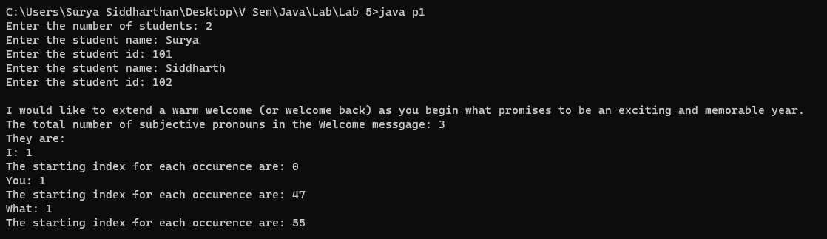

Question:

Create a class called Healthcare that keeps track of the patients name, the patient id, roomcount, and room number for a hospital. Use appropriate data types for these fields. Write two constructors for the class to initialize the instance variables with values (specific to the domain). For the formal parameters, use the same variable names as your instance variables.

* Use **“this”** keyword to distinguish between the instance variables and the parameter variables.
* Invoke current class method using ‘this’ keyword.
* Include a roomCheck () static method for the class. Include a patientcheck() method that accepts a this keyword as parameter.
* Include two methods vacate (patient ID) and admit (Patient ID) for the class. “vacate” and “admit” methods should adjust the room count when a patient vacates the room and when a new patient is admitted appropriately. Use **“this”** keyword to return the instance variables.

The program should keep track of the total roomcount and display the status of rooms available along with the patient-details.

# Code:

import java.util.Scanner;

class HealthCare {

static int capacity = 10, count = 0;

static boolean[] occupied = new boolean[capacity];

private String patient_name; private int patient_id; private int room_no;

static int check_availability() { for(int i = 0; i < capacity; i++) {

if(occupied[i] == false) { return i;

}

}

return -1;

}

HealthCare(String patient_name, int patient_id, int room_no) {

this.patient_name = patient_name; this.patient_id = patient_id; this.room_no = room_no;

count++; occupied[room_no] = true;

}

HealthCare(String patient_name, int room_no) { this.patient_name = patient_name; this.patient_id = (int)Math.random() / 10000; this.room_no = room_no;

count++; occupied[room_no] = true;

}

HealthCare(int patient_id, int room_no) { this.patient_name = "John Doe"; this.patient_id = patient_id; this.room_no = room_no;

count++; occupied[room_no] = true;

}

private void patient_name(HealthCare h) { System.out.println("The patient's name is: "

+ h.patient_name);

}

private void patient_id(HealthCare h) { System.out.println("The patient's id is: " +

h.patient_id);

}

void display_name_and_id() { patient_name(this); patient_id(this);

}

void vacate_patient() { occupied[room_no] = false; count--;

}

}

public class p2 {

public static void main(String args[]) { Scanner sc = new Scanner(System.in);

HealthCare h[] = new HealthCare[HealthCare.capacity];

System.out.print("Enter the number of patients: ");

int n = sc.nextInt(); for(int i = 0; i < n; i++) {

sc.nextLine(); String name; int id;

System.out.print("Enter the patient's

name: ");

");

name = sc.nextLine(); System.out.print("Enter the patient's id:

id = sc.nextInt(); int room_no =

HealthCare.check_availability();

if(room_no != -1) {

h[room_no] = new HealthCare(name, id,

room_no);

}

}

are: ");

{

System.out.println("The patient's details for(int i = 0; i < HealthCare.capacity; i++)

if(h[i] != null &&

HealthCare.occupied[i]) {

h[i].display_name_and_id();

}

}

System.out.println("The total count is: " + HealthCare.count);

h[1].vacate_patient(); h[0].vacate_patient();

System.out.println("After vacating the first

2 patients, the count is: " + HealthCare.count); sc.close();

}

}

# Output:

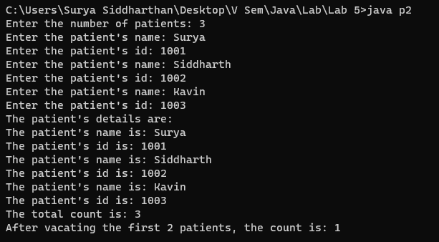

Question:

In your chemistry laboratory, you have taken eight observations for an experiment. The mean and variance for your observations are 11 and 11.25. Assume, your laboratory notebook is missing and you remember only six observations out of eight which you have noted. The six observations you remember are 7, 8, 11, 13, 13 and 14.Write a java program that considers this scenario and finds the remaining two missed observations.

# Code:

import java.util.Scanner; public class p3 {

public static void main(String[] args) { double mean, variance;

");

Scanner sc = new Scanner(System.in); System.out.print("Enter no of observations:

int n = sc.nextInt(); System.out.print("Enter the Mean: "); mean = sc.nextDouble(); System.out.print("Enter the Variance: "); variance = sc.nextDouble();

double[] observations = new double[n - 2];

System.out.println("Enter the

observations:");

for(int i = 0; i < n - 2; i++) observations[i] = sc.nextDouble();

double x, y, z; x = n * mean;

for(int i = 0; i < n - 2; i++) x -= observations[i];

y = n * variance;

for(int i = 0; i < n - 2; i++)

y -= (double)Math.pow(observations[i] -

mean, 2);

z = y - (2 * mean * mean) + (2 * mean * x); double a, b, c;

a = 2;

b = -2 * x;

c = (x * x) - z;

double d = (b * b) - (4 * a * c); double r1;

if(d >= 0) {

r1 = (-b - Math.sqrt(d)) / (2 * a); if(r1 >= 0) {

double r2 = x - r1;

System.out.println("The two missing observations are " + String.format("%.2f", r1) + " and " +String.format("%.2f", r2));

}

else {

System.out.println("The missing observations cannot be found");

}

}

sc.close();

}

}

# Output:

